Power Bi Project Topic: Global Security Threats 2015-2024

Introduction
The dataset and data visualization analysis is based on cybersecurity threats that countries have faced between 2015-2024. The dataset contains columns: Country, Year, Attack Type, Target Industry, Financial Loss (in Million $),Number of Affected Users, Attack Source, Security Vulnerability Type, Defense Mechanism Used, Incident Resolution Time (in Hours).In this project, we will analyze dashboard reports and answer the questions based on the data visualization and study what the reports say.

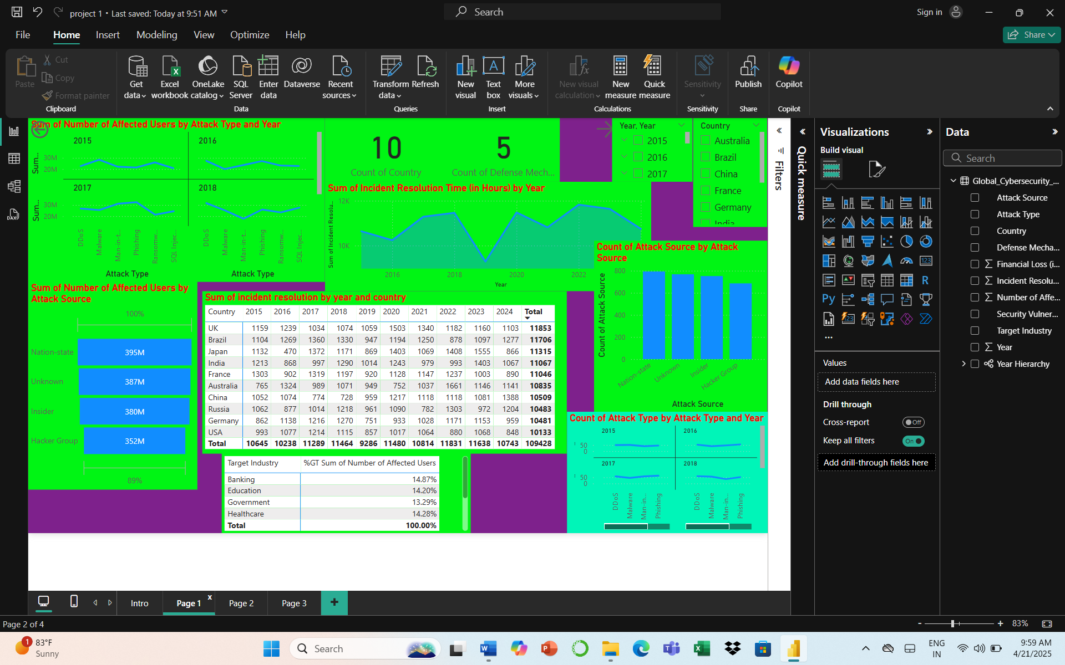
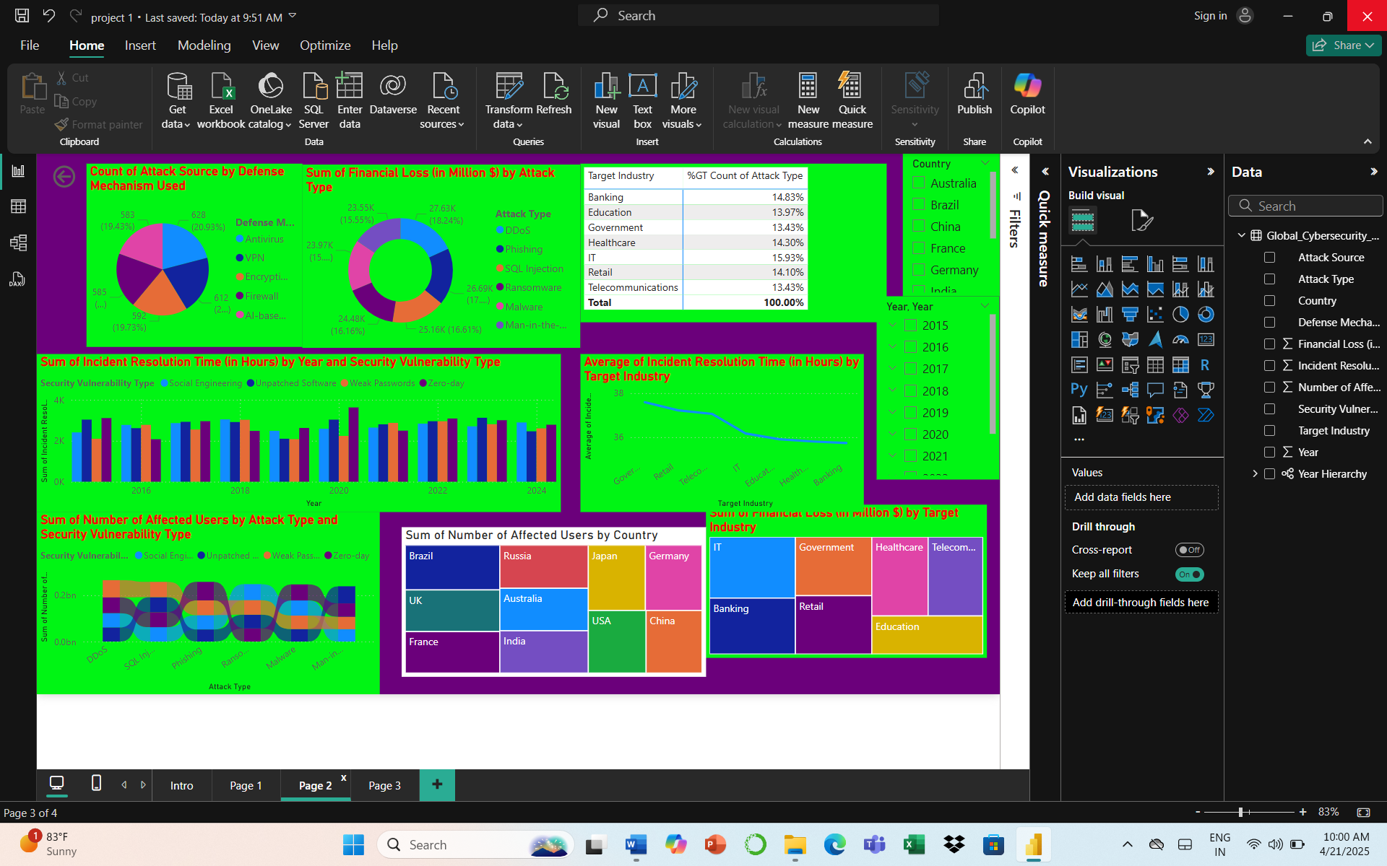
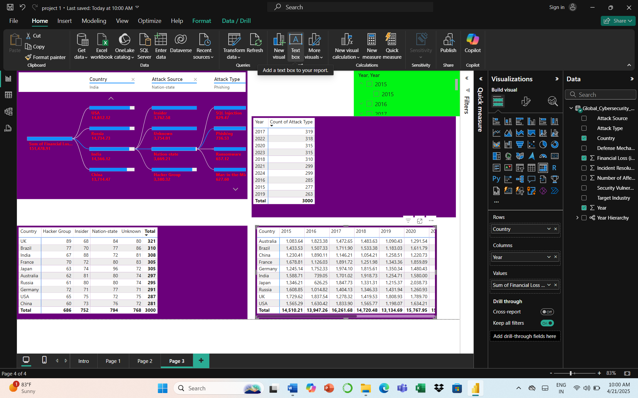

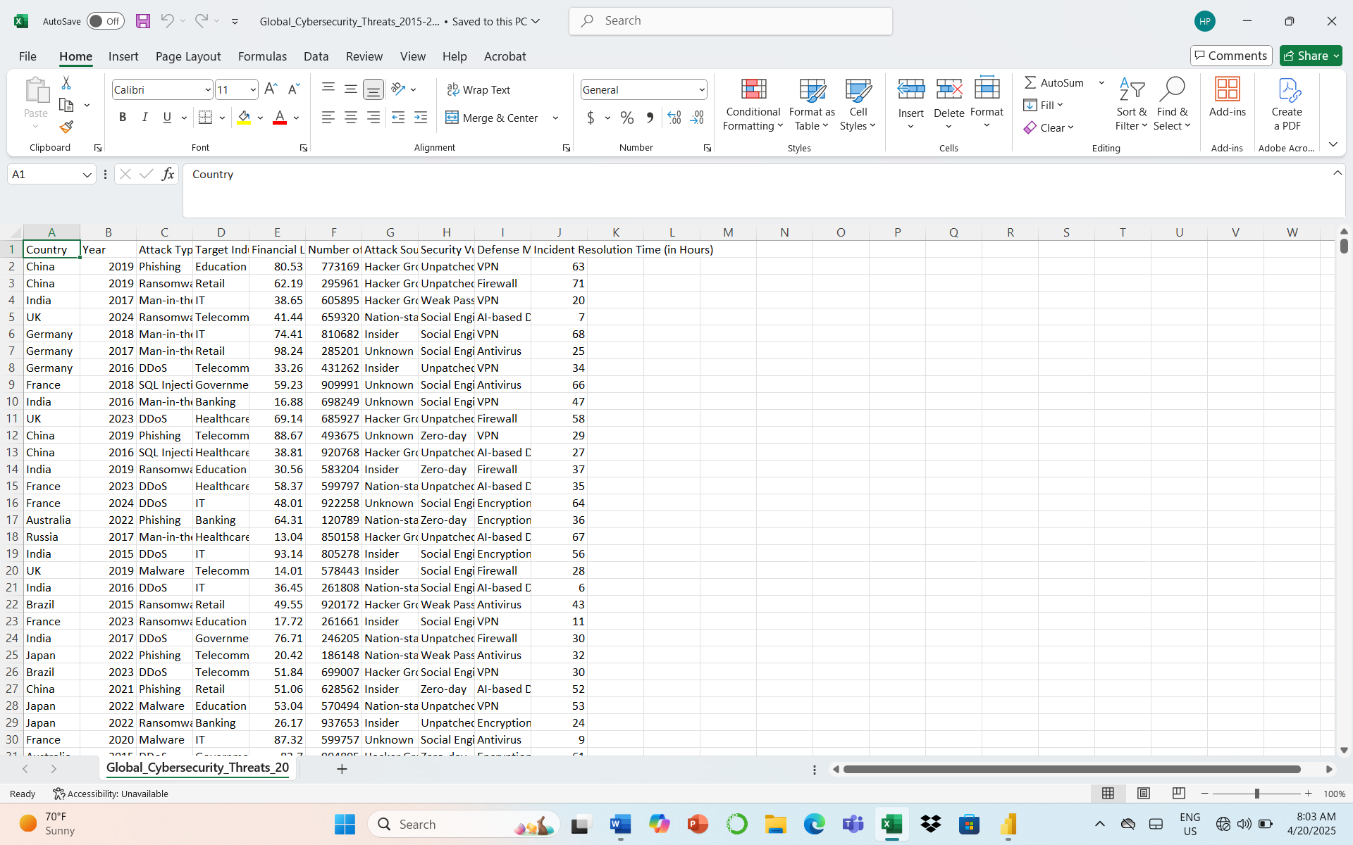

Questions for data visualization and analysis

- What are the most common types of cybersecurity threats from 2015 to 2024?
Answer: From 2015 to 2024, phishing,Ddos is observed to be most common types having highest number of attacks.
- Which countries reported the highest number of cybersecurity incidents each year?
Answer: UK is reported to have highest number of cybersecurity incidents each year.
- How has the total number of cyber attacks changed over the years?
Answer: The trend is seen ups and down over the years between 2015-2024.Where highest attacks took in 2017 with 319 as count of attack in the said year.Then again in 2020, since covid-19 pandemic took place and many started going online , the number thereby increased in 2020 with 318 and then it came down in the year 2024.
- Which sectors (finance, healthcare, government, etc.) were targeted the most by financial loss?
Answer: The IT sector were targeted the most $ 24.8093 billion financial loss, followed by Banking and Government sector respectively.
- Which attack source affected most users?
Answer: Nation-State by 395 million users.
- Which countries experienced the highest total financial loss due to cyber attacks in the year 2020?
Answer: Australia with $12.94 billion financial losses.
- What percentage of cyber attacks targeted each industry sector globally?
Answer: 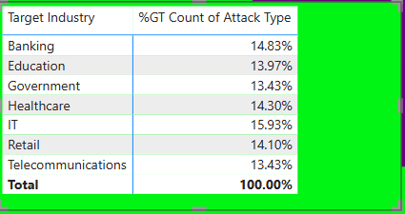
- Which countries had the highest number of users affected by cybersecurity incidents?
Answer:Brazil,UK,France
- Which types of attacks resulted in the highest financial losses globally?
Answer:Ddos,Phishing and SQL Injection
- What are the most frequently exploited security vulnerabilities in cyber attacks from 2015 to 2024?
Answer: Zero day is the most exploited security vulnerability from 2015-2024. With most incidents in years 2015,2017,2019,2020 and 2022.
- Which industries had the longest and shortest average incident resolution times?
Answer: Government highest with average 37.59 hrs and shortest average is Banking 35.74 hours.
- Which defense mechanisms were most commonly used to respond to cyber threats?
Answer: Antivirus,VPN and Encryption with 20.93%, 20.4 %and 19.73 % respectively.
- Which attack sources were most commonly reported in different countries?
Answer : Nation state is many countries.

